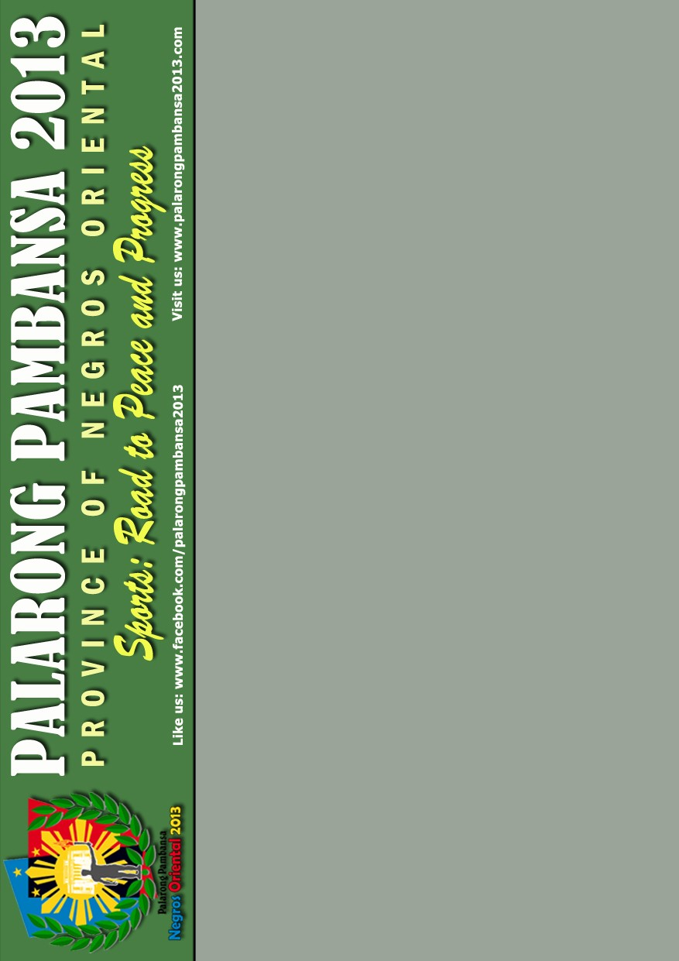

OPENING CEREMONIES

**April 21, 2013 @ 4:30 P.M.**

**Governor Mariano Perdices Memorial Stadium**

**Part I Civic Military Parade**

2:30 PM Assembly Time

Silliman University Campus

3:30 PM Parade

**Part II - Opening Program**

**Entrance**

Youth Volunteers, Executive Committee & Local Officials

Officiating and Technical Officials, NegOr Bolt & Delegates

**Entrance of Colors**

Philippine Flag , Provincial Banner, City Banner, NegOr Olympians

Flaglets (Boy Scouts and Girls Scouts )

**Raising of the Philippine Flag**

Negros Oriental Symphony Orchestra & Choir

Philippine National Police

**Sidlakang Negros Hymn**

Negros Oriental Symphony Orchestra & Choir

Philippine National Police

**Ecumenical Prayer**

**PRAYER** **Rev. Fr. Thadeu Enrique Balongag**

**Ustadz Abdulmaula Wahab Muhsin Rev. Jonathan R. Pia**

**SONG OF PRAISE**

**Manolito Saldivar, Kyle Lemuel Juliano Rackim S. Tahir, Kent Michael Jugador**

**& Chantel Danielle Chua Tan**

**Prelude** **Palihi Ritual**

Foundation University Buglas Dance Troupe

**Welcome Greetings Hon. Manuel T. Sagarbarria**

Mayor, Dumaguete City

**Hon. Roel R. Degamo**

Governor, Negros Oriental Province

**Entrance of the Palarong Pambansa Banner**

**Turning-over of the Palarong Pambansa Banner**

From: **Gov. Amado T. Espino Jr.**

**Dir. Teresita Velasco**

To: **Gov. Roel R. Degamo,**

**Mayor Manuel T. Sagarbarria**

**& Dir. Carmelita T. Dulangon**

Region VII Regional Director

OPENING CEREMONIES

**April 21, 2013 @ 4:30 P.M.**

**Governor Mariano Perdices Memorial Stadium**

**Part I Civic Military Parade**

2:30 PM Assembly Time

Silliman University Campus

3:30 PM Parade

**Part II - Opening Program**

**Entrance**

Youth Volunteers, Executive Committee & Local Officials

Officiating and Technical Officials, NegOr Bolt & Delegates

**Entrance of Colors**

Philippine Flag , Provincial Banner, City Banner, NegOr Olympians

Flaglets (Boy Scouts and Girls Scouts )

**Raising of the Philippine Flag**

Negros Oriental Symphony Orchestra & Choir

Philippine National Police

**Sidlakang Negros Hymn**

Negros Oriental Symphony Orchestra & Choir

Philippine National Police

**Ecumenical Prayer**

**PRAYER** **Rev. Fr. Thadeu Enrique Balongag**

**Ustadz Abdulmaula Wahab Muhsin Rev. Jonathan R. Pia**

**SONG OF PRAISE**

**Manolito Saldivar, Kyle Lemuel Juliano Rackim S. Tahir, Kent Michael Jugador**

**& Chantel Danielle Chua Tan**

**Prelude** **Palihi Ritual**

Foundation University Buglas Dance Troupe

**Welcome Greetings Hon. Manuel T. Sagarbarria**

Mayor, Dumaguete City

**Hon. Roel R. Degamo**

Governor, Negros Oriental Province

**Entrance of the Palarong Pambansa Banner**

**Turning-over of the Palarong Pambansa Banner**

From: **Gov. Amado T. Espino Jr.**

**Dir. Teresita Velasco**

To: **Gov. Roel R. Degamo,**

**Mayor Manuel T. Sagarbarria**

**& Dir. Carmelita T. Dulangon**

Region VII Regional Director



**Hoisting of the Palarong Pambansa Banner**

**- Br. Armin A. Luistro FSC**

**- ASec. Tonisito M. C. Umali, Esq.**

**- Gov. Roel R. Degamo**

**- Mayor Manuel T. Sagarbarria**

**Hoisting of the Delegation Banners**

**- Regional Directors**

**- PESS Chiefs**

**Lighting of the Cauldron**

- **Joey Barba**

(24th SEA Games Gold Medalist)

**- Jennifer D. Chan**

(SEA Games Gold Medalist)

**- Mark Javier**

(2008 Beijing Olympics & 2012 London Olympics)

**- Silliman University Kahayag Dance Troupe**

**Song Rendition - Mr. Manolito Saldivar**

Pinoy Got Talent Finalist

**Athletes' Oath of Amateurism**

**Carl Christian Mari**

Palaro Gold Medallist

**Officiating Officials' Oath of Conduct**

**Mr. Cesar S. Abalon**

Deputy Secretary-General, 2013 Palarong Pambansa

**Introduction of the Guest of Honor and Speaker**

**Tonisito M. C. Umali, Esq.**

Assistant Secretary

Secretary-General, 2013 Palarong Pambansa

**Keynote Address**

**Hon. Ricardo R. Garcia**

Chairman, Philippine Sports Commission (PSC)

**Declaration of the Formal Opening of the**

**2013 Palarong Pambansa**

**Br. Armin A. Luistro FSC**

Secretary, Department of Education

**Palaro Theme Song**

**Quartet**

**Negros Oriental Symphony Orchestra and Choir**

**Ground Performance Negros Oriental Talents**

**Fireworks Display**

**Exit Parade Delegates**

**Ms. GlYnda T. Descuatan**

Lady of Ceremony

**Hoisting of the Palarong Pambansa Banner**

**- Br. Armin A. Luistro FSC**

**- ASec. Tonisito M. C. Umali, Esq.**

**- Gov. Roel R. Degamo**

**- Mayor Manuel T. Sagarbarria**

**Hoisting of the Delegation Banners**

**- Regional Directors**

**- PESS Chiefs**

**Lighting of the Cauldron**

- **Joey Barba**

(24th SEA Games Gold Medalist)

**- Jennifer D. Chan**

(SEA Games Gold Medalist)

**- Mark Javier**

(2008 Beijing Olympics & 2012 London Olympics)

**- Silliman University Kahayag Dance Troupe**

**Song Rendition - Mr. Manolito Saldivar**

Pinoy Got Talent Finalist

**Athletes' Oath of Amateurism**

**Carl Christian Mari**

Palaro Gold Medallist

**Officiating Officials' Oath of Conduct**

**Mr. Cesar S. Abalon**

Deputy Secretary-General, 2013 Palarong Pambansa

**Introduction of the Guest of Honor and Speaker**

**Tonisito M. C. Umali, Esq.**

Assistant Secretary

Secretary-General, 2013 Palarong Pambansa

**Keynote Address**

**Hon. Ricardo R. Garcia**

Chairman, Philippine Sports Commission (PSC)

**Declaration of the Formal Opening of the**

**2013 Palarong Pambansa**

**Br. Armin A. Luistro FSC**

Secretary, Department of Education

**Palaro Theme Song**

**Quartet**

**Negros Oriental Symphony Orchestra and Choir**

**Ground Performance Negros Oriental Talents**

**Fireworks Display**

**Exit Parade Delegates**

**Ms. GlYnda T. Descuatan**

Lady of Ceremony