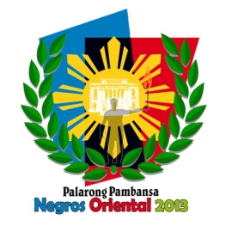
Republic of the Philippines
Department of Education
Region VII, Central Visayas
DIVISION OF NEGROS ORIENTAL
www.depednegor.org

2013 Palarong Pambansa
CLOSING CEREMONIES
April 27, 2013 @ 5 P.M.
Don Mariano Perdices Memorial Stadium

Part I Friendship Parade around the Oval

Part II
Nationalistic Song
Negros Oriental Symphony Orchestra
Invocation
Negros Oriental Symphony Orchestra
Celebration Show
Negros Oriental’s Best Dance Crews

Message of Appreciation Dr. Carmelita T. Dulangon
OIC-Regional Director, DepEd Region VII

Awarding of 2013 Palarong Pambansa General Championship
Hon. Teonisito Umali Jr.
Assistant Secretary
Dr. Carmelita T. Dulangon
OIC-Regional Director, DepEd Region VII
Hon. Roel R. Degamo
Governor, Negros Oriental Province
Hon. Manuel T. Sagarbarria
Mayor, Dumaguete City

Farewell Message
Hon. Roel R. Degamo
Governor, Negros Oriental Province
Hon. Manuel Sagarbarria
Mayor, Dumaguete City
Extinguishing of Palaro Flame

Flashback
Video Presentation of the 2013 Palarong Pambansa Games

Lowering of the Flags
Delegation Banners
Palarong Pambansa Banner
Philippine Flag
Human Peace Sign

Laser and Lights Show Midnasty
Lady of Ceremonies: Ms. Glena Dutch & Geo Burdeos
Ms. Silliman 2011
Ms. Earth Philippines-2nd runner up

