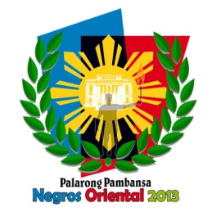
Republic of the Philippines
Department of Education
Region VII, Central Visayas
DIVISION OF NEGROS ORIENTAL
www.depednegor.net

2013 Palarong Pambansa
Arrival Ceremonies
April 15, 2013 @ 6PM
Negros Oriental Provincial Capitol Foreground

- Invocation
- Philippine National Anthem
- Welcome Address
Hon. Roel R. De Gamo
Governor, Province of Negros Oriental

- Flag Hoisting
Negros Oriental Banner
Dumaguete City Banner
Delegation Banners
-Regional Directors and PESS Chief or any representative
- Sandurot Ceremony- Exchange of gifts/tokens
Regional Directors to the Governor
Governor to the Regional Directors
- Welcome dance
Likos, Canlaon City
- Cocktails

Hosts:

Elizabeth Joy Divinagracia & Eugene Calingacion

